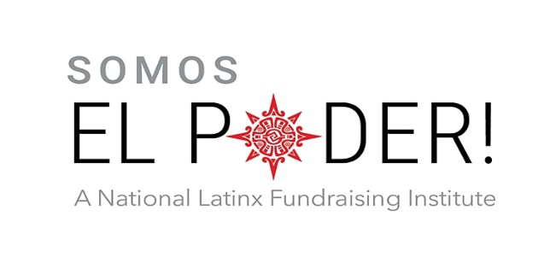

Program Associate, Somos El Poder
Somos El Poder: A National Latinx Fundraising Institute is hiring its first Program Associate to help build up the professional development offering, community, and membership of SEP. The PA will be highly entrepreneurial, creative, and passionate about the mission of SEP.
​Somos El Poder is dedicated to improving and growing fundraising at Latinx focused nonprofits in our nation. We work with any Latinx focused nonprofit regardless of size or budget. We are a nonprofit and accessible provider of support, professional development, best practices, training, and more. We also work to promote Development as a career for Latinx and academic studies of Latinx and fundraising
Our mission is the advancement of Latinx in the US today. We believe in the inherent strength, ingenuity, and self-reliance of our people to solve their challenges and defend our rights. We believe that providing significant financial resources to those working on the issues of our people will advance our collective future.
Job Description
Hours: 30 hours a month
Supervisor: Armando Zumaya, Founder
Structure: Weekly Check in Meetings for 30 minutes, Board Meetings, Remote work
Key Duties
- Call and Email Latinx nonprofit leaders to engage them as potential members
- Develop and implement strategies to build membership engagement
- Build membership and Latinx nonprofit simple database
- Email Class announcements on a regular basis
- Build SEP on social media
- Create an SEP Monthly Newsletter with content from members and fundraising
- Assist when needed in development of SEP Curriculum

